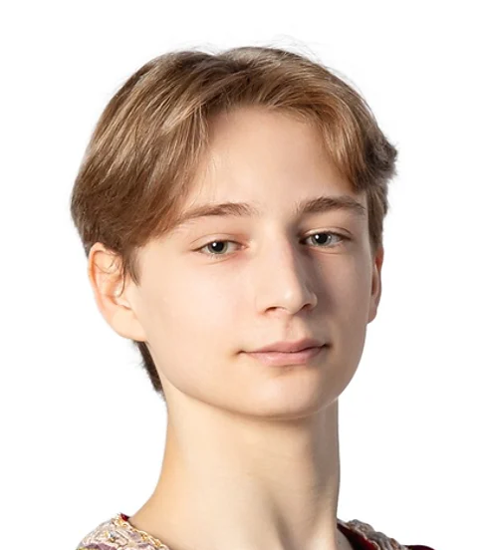
Ellis Wolf Annunziata
Email: EllisWolfAnnunziata@gmail.com Height: 1.77 M / 5 Ft. 9.5 In.
Phone: +1(857-361-2441) DOB: 6/19/2006 (Age 19)
EllisWolfAnnunziata.com Citizenship: USA

TRAINING
2024 - Current Pacific Northwest Ballet (PNB) - Professional Division (PD), Peter Boal, Artistic Director
Faculty: Peter Boal, Le Yin, Kurt Froman, Eric Hipolito Jr.
2018 - 2024 Northeast School Of Ballet, (NSB) - Conservatory Trainee, Denise Cecere, Artistic Director
Faculty: Jean-Pierre Bonnefoux, Erika Lambe, Joseph Jefferies, Rhonda Lee, Caitlin Pesce
2014 - 2017 Northeast School Of Ballet, (NSB) - Student, Denise Cecere, Artistic Director

Summer Programs:
2025: Chautauqua School of Dance (CHQ; Pre-Pro)
2023- 2024: Pacific Northwest Ballet (Advanced C level)
2021- 2022: Chautauqua School of Dance (Festival)
2020: Pacific Northwest Ballet (virtual)
2019: Chautauqua School of Dance (Workshop)
2017- 2018: Northeast School of Ballet

PERFORMANCE EXPERIENCE (Selected)

Performances Role(s) School/Company: Year
Shindig (John-Pierre Bonnefoux) Lead male/Pistolerro CHQ School: 2025
Serenade (George Balanchine) Male corps CHQ School: 2025
We Danced Through Life (Sasha Janes) 2nd Pas de deux CHQ School: 2025
Sparrow (Stanton Welch) Corps CHQ School w/HBII: 2025
The Four Temperaments (George Balanchine) 2nd Theme PNB School: 2025
Next Step (Amanda Morgan & Lily Wills) Corps PNB School: 2025
Beauty and the Beast (Bruce Wells) Courtier, Villager PNB School: 2025
Sleeping Beauty (Boal, after Petipa) Garland Dance, Footmen, Violin Page PNB Company: 2025
The Nutcracker (George Balanchine) Hot Chocolate Corps, Father, Mouse PNB Company: 2024
Gaîté Parisienne (Joseph Jefferies) The Peruvian NSB: 2024
Les Sylphides (Mikhail Fokine, staging: Jefferies) Poet NSB: 2024
Carmen (Joseph Jefferies) Don Jose NSB: 2023
Urban Nutcracker (Tony Williams) Omar, Raggedy Andy City Ballet Boston: 21-22
The Nutcracker (Denise Cecere, Joseph Jefferies) Prince, Rat King, Gma, Russian, Chinese NSB: 2014-24
Cinderella (Denise Cecere, Joseph Jefferies) The Court Jester NSB: 2022

AWARDS & SCHOLARSHIPS

2024-current: Pacific Northwest Ballet - Partial Scholarship for PD program
2023 & 2024: Pacific Northwest Ballet - Full Tuition Merit Scholarship
2021,2022, 2025: Chautauqua School of Dance - Full Merit Scholarship; received peer award for “Funniest Dancer”

ADDITIONAL INFORMATION

Academic: TEC Connection Academy High School Graduate (6/2024): GPA: 3.96/4.0; Abigail Adams Scholar
Skills: Youtube, Video editing, Adobe Premiere Pro and Photoshop, Comedy
REFERENCES

Peter Boal (Artistic Director, Pacific Northwest Ballet): Peter@pnb.org
Sasha Janes (Bonnefoux McBride Artistic Director of Chautauqua School of Dance): sjanes@chq.org
Joseph Jefferies (Assoc. Director, Conservatory at Northeast School of Ballet): northeastschoolofballet@gmail.com

